**Study the absorption of the functional groups**

**Aim**

The aim of this set of tasks is to give students the opportunity to study the relationship between the frequency absorption and the functional groups.

**Learning outcomes:**

After completing the set of these tasks, students will be able to:

1. Recognize the most important absorption bands of an IR spectrum: vibration frequency and compound characteristics.
2. Match the important bands of an IR spectrum with the corresponding functional groups.
3. Distinguish the different absorption bands for a variety of organic compounds, such as alcohols, aldehydes, ketones, ethers, esters, amines, nitriles.
4. Identify the four main regions of an IR spectrum and match them with the functional groups.
5. Analyze an IR spectrum in order to identify the organic compound.

**Task 1.** The **C-H** bond is a common bond in organic compounds, but its IR absorbance varies depending on the types of organic compounds that belongs to.

Study the following seven different compounds and fill the table below by providing the wavenumber that represents the C-H bond.

|  |  |
| --- | --- |
| **Organic compound** | **Wavenumber (nm-1)** |
| Alcohol |  |
| Ketone |  |
| Alkyne |  |
| Acid |  |
| Ether |  |
| Ester |  |
| Nitrile |  |

**Task 2.** The **O-H** bond can be identified in a very specific absorption band on an IR spectrum depending on the wavenumber and band shape.

Study the IR spectra of the following two compounds: 2-propanol and propanoic acid and fill the table below by providing the wavenumber that represents the O-H bond. Observe the difference in the IR bands based on the type of the organic compound and leave a comment about the IR band in the “Details” text area.

|  |  |  |
| --- | --- | --- |
| **Organic Compound** | **Wavenumber** | **Details** |
| 2- propanol |  |  |
| propanoic acid |  |  |

Please could you provide us more details explaining why there is a difference between the O-H bond in the two compounds?

………………………………………………………………………………………………………………………………………………………………………………………………………………………………………………………………………………………………………………………………………………………………………………………………………………………………………………………………………………………………………………………………………………………………………………………………

**Task 3.** In this task the difference between **carbon and oxygen bonds** will be discussed. There are mainly two types of carbon and oxygen bonds that can be found either in alcohols, ethers, acids and esters (**C-O**) or aldehydes, ketones, acids or esters (**C=O**). Complete the table below by providing the wavenumber of absorption of these two functional groups in every given organic compound.

|  |  |  |  |  |  |
| --- | --- | --- | --- | --- | --- |
| **Carbon-Oxygen bond** | **2-propanol** | **2-butanone** | **propanoic acid** | **methoxybenzene** | **propylacetate** |
| C-O |  |  |  |  |  |
| C=O |  |  |  |  |  |

**Task 4.** The carbon-carbon bond (**C-C**) is the fundamental bond in all the organic compounds. Match the following compounds based on the C-C bond. Then click on each compound to view its spectrum and complete the table below by providing the wavenumber of absorption next to the corresponding bond.

|  |  |  |
| --- | --- | --- |
| **Compound** | **Bond** | **Wavenumber** |
| i. Methoxybenzene | a. C=C |  |
| ii. 1,5-cyclooctadiene | b. C-C |  |
| iii. 1-hexyne | c. C≡C |  |
| iv. 2-propanol | d. aromatic C-C |  |
|  | | | |

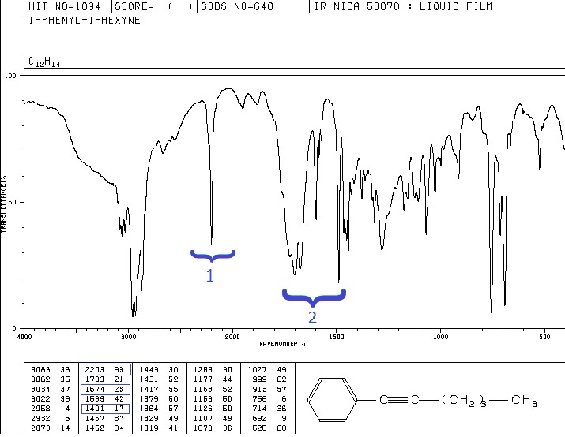**Task 5.** Below you can find the IR spectrum of 1-phenyl-1-hexyne. On the spectrum there are two highlighted band areas (1 and 2). Write on the spectrum which band represents the aromatic C-C and C≡C.

**Task 6.** The C≡N bond has a sharp band on an IR spectrum. To observe it, click on the acetonitrile compound and then complete the table below.

|  |  |  |
| --- | --- | --- |
| **Nitrile** | **Wavenumber** | **Frequency range (nm)** |
| C≡N |  |  |

**Task 7.** The following IR spectra represent two nitrile compounds:   
propionitrile (C3H5N) and pivalonitrile (C5H9N). Highlight on the spectra the C≡N band.

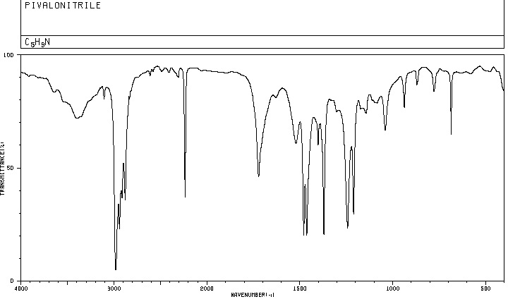

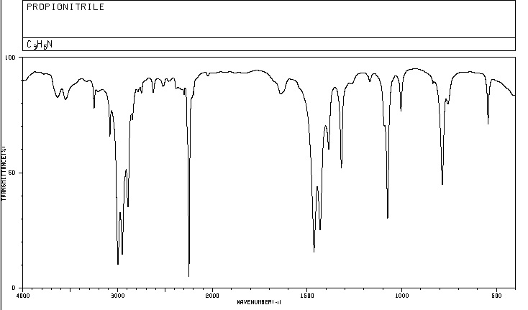

**Task 8.** The **N-H** bond is the functional group of amines. Click on the dimethylphenylamine to study its spectrum and then complte the table below

|  |  |
| --- | --- |
| **Amine** | **Wavenumber** |
| N-H |  |

According to the simulation right hand side table, what is the significant difference between primary, secondary and tertiary amines?

………………………………………………………………………………………………………………………………………………………………………………………………………………………………………………………………………………………………………………………………………………………………………………………………………………………………………………………………………………………………………………………………………………………………………………………………

**Task 9.** Match the amines with each spectrum below.

|  |  |
| --- | --- |
| 1. propylamine (C3H9N) | Spectrum 1 |
| 1. diethylamine (C4H11N) | Spectrum 2 |
| 1. triethylamine (C6H15N) | Spectrum 3 |

Spectrum 1:

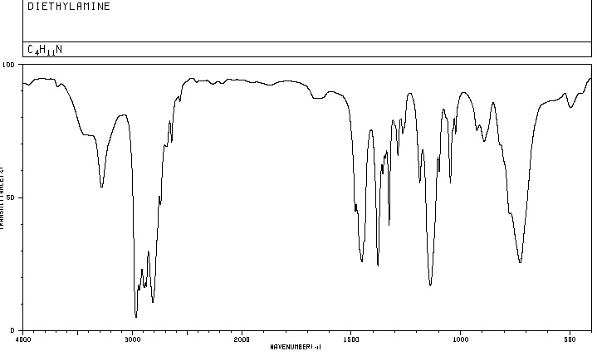

Spectrum 2:

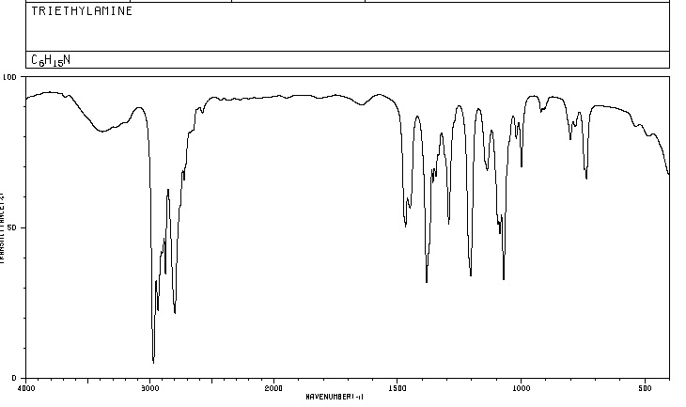

Spectrum 3:

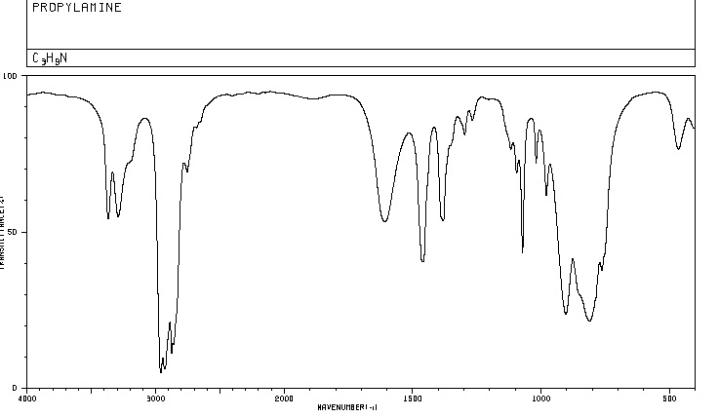

**Task 10.** Organic compounds with the molecular formula CnH2n+2O can be either saturated alcohols or ethers. How could you distinguish these two compounds based on their IR spectra?

………………………………………………………………………………………………………………………………………………………………………………………………………………………………………………………………………………………………………………………………………………………………………………………………………………………………………………………………………………………………………………………………………………………………………………………………

**Task 11.** Compare the IR spectra of methoxybenzene and 2-propanol and explain the difference.

………………………………………………………………………………………………………………………………………………………………………………………………………………………………………………………………………………………………………………………………………………………………………………………………………………………………………………………………………………………………………………………………………………………………………………………………

**Task 12.** Match the ether and the alcohol with each spectrum below.

|  |  |  |  |
| --- | --- | --- | --- |
| 1. Diethylether | | | Spectrum 1 |
| 1. 2-butanol | | | Spectrum 2 |
|  |  | | |
| Spectrum 1 |  | | |
|  | | | |
| Spectrum 2 | |  | |
|  | | | |

**Task 13.** Organic compounds with the molecular formula CnH2nO2 can be either saturated monocarboxylic acids or esters. How could you distinguish these two compounds based on their IR spectra?

………………………………………………………………………………………………………………………………………………………………………………………………………………………………………………………………………………………………………………………………………………………………………………………………………………………………………………………………………………………………………………………………………………………………………………………………

**Task 14.** Match the following two IR spectra with the compound (C4H8O2). It could represent either isobutyric acid or ethyl acetate.

|  |  |  |  |
| --- | --- | --- | --- |
| 1. Isobutyric acid | | | Spectrum 1 |
| 1. Ethyl acetate | | | Spectrum 2 |
| Spectrum 1 |  | | | |
|  | | | | |
| Spectrum 2 | |  | | |
|  | | | | |

**Task 15.** According to IR Spectroscopy theory, **the vibration of the molecular bonds** is due to the absorption of radiation. Draw arrows on the compound structural formula in order to represent how the bonds vibrate.

**Stretching:** a change in the length of a bond

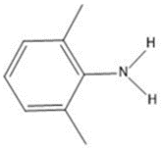**Bending:** a change in the angle between two bonds



**Wagging:** a change in angle between the plane of a group of atoms

**Task 16.** The following IR spectrum is split into four main regions. Give us the representation of the following functional groups on the IR spectrum based on the four main regions.

|  |  |
| --- | --- |
| * C-H * Aromatic C-H * N-H * O-H * C=C * Aromatic C-C | * C-C * C≡C * C=O * C≡N * C-O |
|  | |

|  |  |  |  |
| --- | --- | --- | --- |
| **REGION 1** | **REGION 2** | **REGION 3** | **REGION 4** |
| 1. ………………………… 2. ………………………… 3. ………………………... 4. ………………………... | 1. ……………….….. 2. ……………….….. | 1. ……………….….. 2. ……………….….. | 1. ………………….. 2. ………………….. 3. …………………. |